Cleaning instruction for Kantan Modulator
(1)

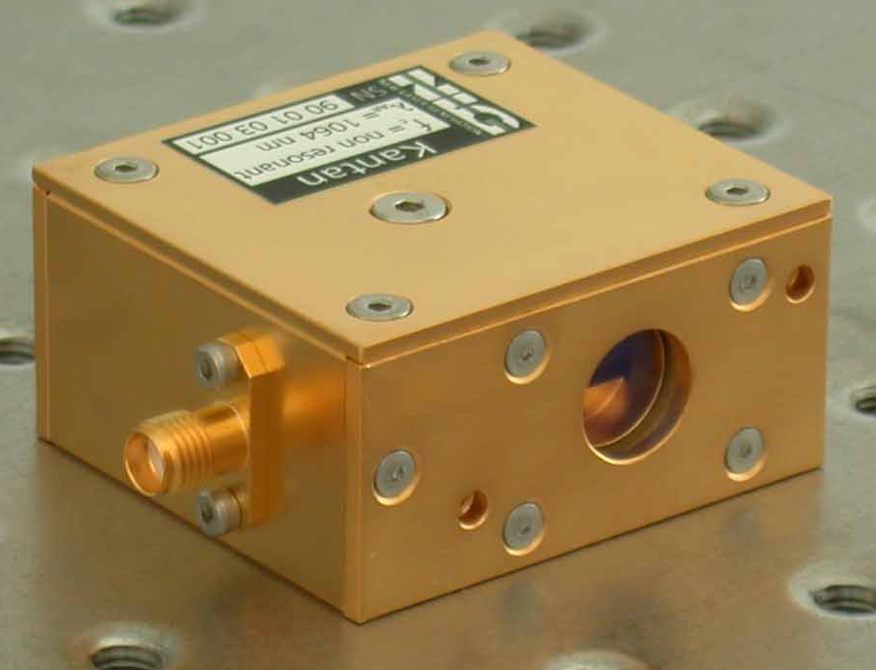
(4)
(2)

(3)

a). Cleaning of the crystal:
1. Remove 4 hex screws (1) of the cover using a 1.5mm allen key
2. Remove the cover (2)
3. Using a hemostat and a folded lens cleaning tissue with one drop of pure methanol (gradient grade), wipe the crystal surfaces several times at the locations marked in the picture below:

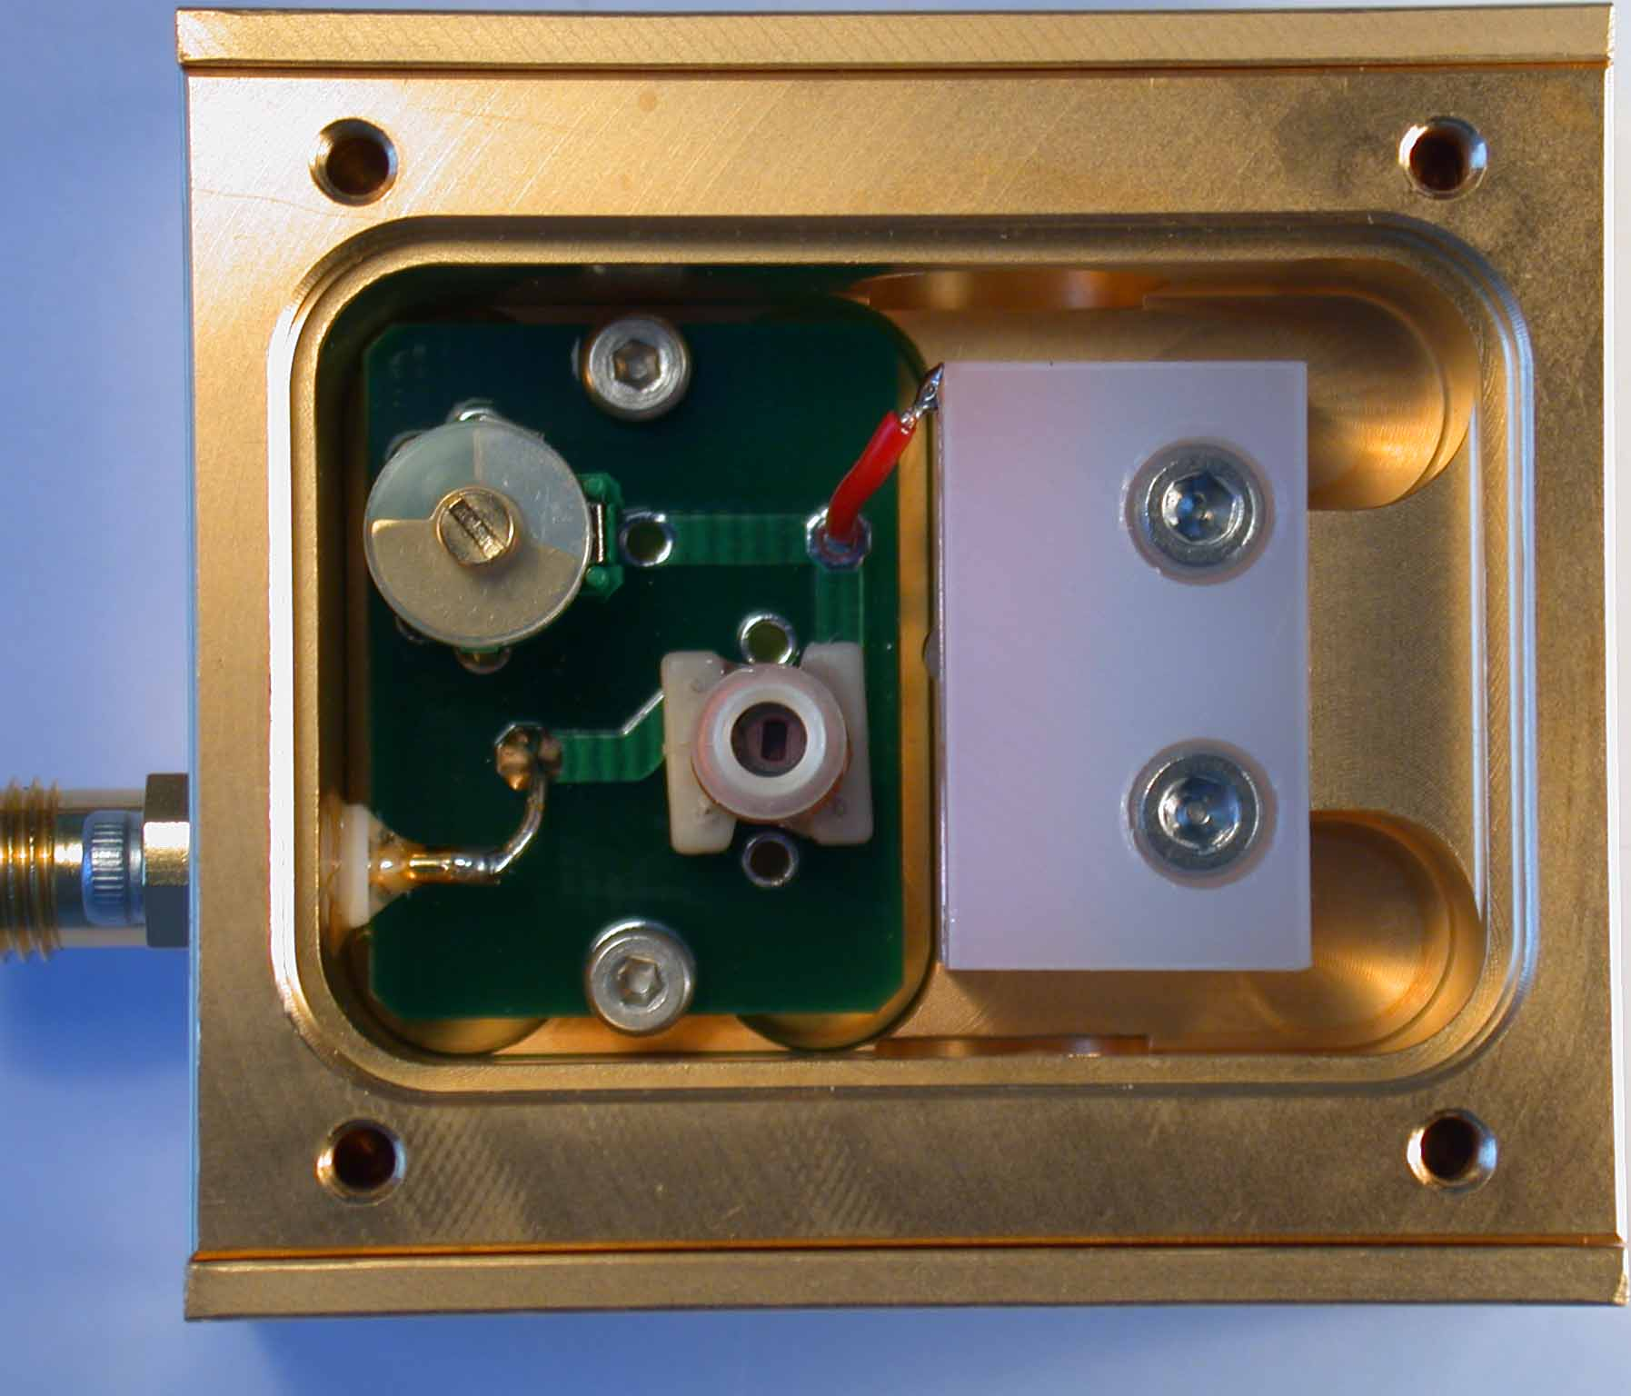
clean
4. Return cover to to housing and tighten screws carefully (do not damage the screw heads by too much force!)

a). Cleaning of the windows:

1. Remove 5 hex screws (3) on each side using a 1.25mm allen key.
2. Remove the side wall (4) carefully, do not let the windows fall down!
3. Clean the windows with lens cleaning tissue and methanol (gradient grade).
4. Reinstall the windows and the side walls.

